Comparison of Traditional OBD-II Diagnostic Software and AI-Based Systems for Predictive Vehicle Maintenance
Rujanac Mirza
Faculty of Information Technologies, University “Džemal Bijedić”, Mostar, Bosnia and Herzegovina
mirza.rujanac@edu.fit.ba
Abstract – This paper examines the differences between traditional OBD-II diagnostic software and AI-based systems used for predictive vehicle maintenance. The first approach is built around reading diagnostic trouble codes, monitoring live data, and supporting fault detection after the vehicle has already recognized an abnormal condition. The second approach relies on data analysis, machine learning, and condition monitoring in order to estimate potential failures before they become critical. The paper explains the fundamentals of both approaches, highlights their practical advantages and limitations, and compares them from the perspective of accuracy, speed, cost, technical complexity, and real-world usability. The goal is to show that OBD-II and AI-based diagnostics should not be viewed as direct opposites, but as two complementary approaches that serve different purposes in modern vehicle maintenance.

Keywords – OBD-II, vehicle diagnostics, diagnostic trouble codes, artificial intelligence, predictive maintenance, automotive software
- Introduction
In the automotive industry, vehicle diagnostics play an important role in identifying problems, improving safety, reliability, and overall performance. As vehicles have more features, such as sensors for recognizing signs, automatic breaking, gear shifting etc. Each manufacturer uses its own implementation of electronic control units (ECUs), therefore the need for accurate and efficient diagnostic methods has become more important.
In today’s world the most common and most used approach to vehicle diagnostics is based on the OBD-II (On-Board Diagnostics) standard, which can read diagnostic trouble codes (DTCs) sent from the ECU. However, there is one main disadvantage when it comes to these OBD-II readers is that their effectiveness depends on the person’s ability to correctly read and recognize the DTC, which can lead to incorrect diagnosis or unnecessary repairs if misunderstood.
Recent growth in artificial intelligence has allowed us to introduce new possibilities in the automotive industry, such as preventing mistakes or improving overall health of our automobile. AI-based systems are trained on large datasets collected from vehicles, and can later analyze data in real time.. Afterwards, the AI diagnostic system can save a lot of person’s time by providing possible causes or patterns associated with a DTC, therefore making the fix quicker and cheaper, improving efficiency and safety. At the same time the AI diagnostic system can predict potential failures before a DTC is triggered, shifting the approach from reactive troubleshooting to proactive maintenance.
This research compares traditional OBD-II diagnostic software with AI-based diagnostic prediction and maintenance systems, focusing on their strengths, limitations, and practical applications in modern vehicles.
- FUNDAMENTALS OF OBD-II DIAGNOSTICS
Vehicle diagnostics has changed considerably over time. What began as a standardized way to detect faults related mainly to emissions has gradually developed into a broader process of monitoring vehicle condition and supporting maintenance decisions. In practice, two approaches are especially important today. The first is the traditional OBD-II diagnostic model, which identifies faults after they have already been recognized by the vehicle’s control system. The second is the AI-based predictive model, which analyzes current and historical data in order to estimate the likelihood of future failures before they become critical. Traditional OBD-II systems are still the most widely used solution in workshops and routine diagnostics, while AI-based systems are becoming more relevant because they introduce a more preventive and data-driven maintenance strategy.
- Traditional OBD-II Diagnostics
OBD-II, short for On-Board Diagnostics II, is a standardized diagnostic system used in modern vehicles to monitor the operation of important vehicle subsystems and report malfunctions. Although its regulatory purpose is strongly connected to emissions monitoring, OBD-II is also widely used in practice to retrieve fault information from systems related to the engine, transmission, and other electronically controlled functions. Its importance lies in the fact that it gives technicians and diagnostic software direct access to fault-related vehicle data through a common interface.
The system operates through the vehicle’s electronic control units, which continuously monitor input from sensors and actuators. When the ECU detects a value or operating condition outside the acceptable range, it stores a diagnostic trouble code, commonly known as a DTC. This code can then be retrieved by connecting a scan tool or diagnostic software to the OBD-II port. In many cases, the process is accompanied by activation of the malfunction indicator lamp, better known as the “Check Engine” light, which informs the driver that the vehicle has detected a fault requiring attention.
One of the main strengths of OBD-II is standardization. Because vehicles follow defined communication rules and connector standards, many diagnostic tools can work across different manufacturers and models, even though some advanced functions may remain manufacturer-specific. This standardization is one of the reasons OBD-II became so widely used in both professional and consumer diagnostics. In a practical sense, OBD-II software usually serves as the first step in fault detection because it allows users to read stored codes, inspect live sensor data, and observe the condition of the monitored system.
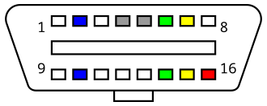
Fig 1. Standard OBD-II connector pinout used for communication between the vehicle and the diagnostic tool.
- OBD-II Diagnostic Software in Practice
Traditional OBD-II diagnostic software is designed mainly to interpret information that has already been generated by the vehicle. In most cases, the software reads stored DTCs, displays freeze-frame data, shows real-time sensor values, and allows fault codes to be cleared after the problem has been addressed. This makes OBD-II tools very useful for confirming that a problem exists and identifying the subsystem in which abnormal behavior was detected.
However, the software itself does not usually determine the full root cause of the fault. It presents the code and associated data, but the final interpretation still depends on the experience and technical understanding of the user. A single DTC may point toward one subsystem while the actual cause may lie elsewhere, such as in wiring, sensor contamination, mechanical wear, or interaction with another component. For that reason, traditional OBD-II software is highly useful, but it is still largely reactive and dependent on human interpretation.
Another important limitation is timing. OBD-II systems are generally designed to detect and report problems after they have reached a defined threshold. In other words, they are very effective at identifying faults that the system has already recognized, but they are far less capable of estimating that a fault is likely to occur in the near future. This reactive nature is one of the main reasons why traditional diagnostics alone may not be sufficient for modern maintenance strategies focused on reliability, reduced downtime, and cost optimization.
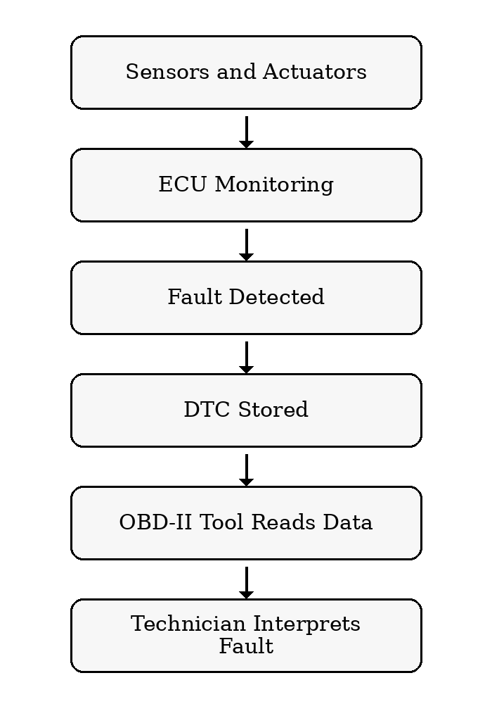
Fig 2. Standard OBD-II connector pinout used for communication between the vehicle and the diagnostic tool.
- AI-Based Predictive Maintenance System
AI-based predictive maintenance follows a different principle. Instead of waiting for a fault code to appear, these systems use large sets of historical and real-time vehicle data to detect patterns associated with abnormal behavior, performance degradation, or likely future failure. In research literature, predictive maintenance is generally described as a strategy based on condition monitoring and data analysis, where maintenance decisions are made according to the estimated health state of the system rather than only after a breakdown or a fixed service interval.
In the automotive field, these systems may analyze sensor readings, fault history, driving conditions, operating load, and usage patterns collected over time. Artificial intelligence, especially machine learning, makes it possible to recognize relationships in this data that are difficult to capture through fixed rules alone. As a result, AI-based diagnostics can support earlier fault recognition, estimate probable component degradation, and suggest that maintenance should be performed before a more serious failure occurs.
The advantage of this approach lies in better planning and more efficient intervention. Instead of reacting only when the vehicle stores a fault code, AI-based systems can warn that a certain component is showing signs of deterioration and may require service soon. This can reduce downtime, prevent secondary damage, and lower maintenance costs. At the same time, these systems also have limitations. Their performance depends heavily on data quality, the relevance of the selected model, and the correctness of training and validation procedures. Poor or incomplete input data can quickly reduce reliability.
- SCANIA Component X dataset
In an era marked by technological advancement and data-driven decision-making, the automotive industry is undergoing a transformative shift, particularly in the realm of vehicle maintenance. Predictive maintenance (PdM) has emerged as a key player in revolutionizing how we care for and optimize the performance of vehicles. This innovative methodology harnesses the power of advanced analytics, sensor technology, and machine learning to predict when vehicle components are likely to fail, allowing for timely and cost-effective maintenance interventions. PdM is paramount for critical components in trucks. This proactive approach to maintenance involves using data, analytics, and monitoring systems to estimate the components’ health state. The SCANIA Component X dataset is a predictive maintenance dataset focused on an anonymized vehicle component referred to as Component X.
Operational data was collected through onboard sensors and stored in vehicle control units, from which it could later be retrieved remotely or during workshop visits. Repair information was gathered from service-related documentation, including invoices and workshop work orders, and vehicles whose component had been replaced or marked as repaired were labeled as failed. Specification data was taken from the production system and contains static technical details about each truck. This research also emphasizes that real-world data collection of this kind is not error-free. Problems such as temporary loss of communication with ECUs, counter resets caused by software updates, incomplete repair history outside official SCANIA workshops, and occasional mismatches between original and current vehicle configuration all had to be considered. To make the dataset publishable, the raw data was then post-processed, anonymized, and partially perturbed while preserving its usefulness for predictive modeling. This means that the dataset reflects real operating conditions much better than a synthetic benchmark, but it also inherits the messiness and imperfections typical of real industrial data.
The data therefore supports a five-class predictive task in which each class represents a different time-to-failure window, ranging from vehicles that are still far from failure to vehicles that are very close to a failure event. This structure makes the dataset well suited for predictive maintenance, since the objective is not only to detect abnormal behaviour in the present, but also to estimate how near a vehicle is to a future failure window.
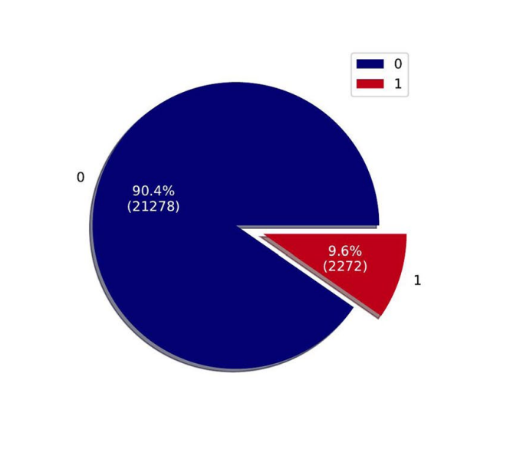
Fig. 3 Visualization of classes in the train set. This chart shows the repair distribution.
After collecting data, some modifications have been made to protect the confidentiality of data for publishing. Regarding temporal representation description, relative times are reported instead of the original timestamps. This is done to capture temporal patterns without revealing specific dates or time points. Repair frequencies and readout frequencies may have been modified and are not necessarily representative of actual truck usage. Moreover, variable names have been omitted for privacy and proprietary reasons, presenting a subset of all available operational and specification data
The proposesd dataset is publicly available and can be accessed on the Swedish National Data Service Website. It is divided into three segments: training, validation and testing.

- Analysis: Reactive OBD-II vs AI Predictive MAINTENACE
The purpose of this chapter is to examine how the reactive OBD-II-style baseline and the AI-based predictive model behave on the same SCANIA Component X dataset, and to explain why their results differ. This comparison should not be interpreted as a direct test of commercial OBD-II software, because the dataset does not contain real diagnostic trouble codes, real OBD-II parameter IDs, or actual ECU malfunction-indicator states. Instead, the research compares two diagnostic ideas: a reactive rule-based baseline representing conventional OBD-II-style logic, and an AI-based predictive system that estimates time-to-failure classes from historical sensor behavior and vehicle specification context..
Before discussing the results, it is important to explain how the reactive baseline is actually calculated. The baseline uses only the *_last features, which represent the most recent sensor value available for each vehicle snapshot. During training, it takes the healthy class 0 rows as a reference group and computes the mean and standard deviation of each last-value feature. For a given signal $j$, the deviation of a current observation from the healthy reference can be written as
$$z_{j}=\frac{|x_{j}-μ_{j}|}{σ_{j}}$$
where $x_{j}$ is the current sensor value, $μ_{j}$ is the healthy-class mean, and $σ_{j}$ is the healthy class standard deviation. Not every deviation is treated as meaningful. Only the part that exceeds the normal threshold contributes to the anomaly core. This exceedance is defined as:
$$e_{j}=max⁡(z_{j}-3.0, 0)$$
which means that small deviations are ignored, while larger deviations increase the anomaly contribution of that signal. The final anomaly score for one vehicle row is then obtained by summing these exceedances across all last-value features:
$$A= \sum_{j=1}^{m}{e_{j}}$$
Where m denotes the number of last value sensor features used by the baseline. After that, the baseline maps the anomaly score into one of the five time-to-failure classes. It does this by computing the median anomaly score for each class in the training data and using the midpoints between those medians as class boundaries. In other words, the saved reactive prediction is not based on learned temporal failure patterns, but on how abnormal the latest sensor profile looks relative to healthy behavior.
This design already explains a lot about the baseline’s behavior. Its main strength is that it is easy to understand. It follows the same broad logic that people associate with conventional diagnostics: observe the current state, compare it to normal operation, and trigger a stronger response as the deviation grows. The project also adds a readable OBD-style presentation layer on top of the saved baseline output, including proxy MIL status, pending/confirmed/severe trigger counts, and rule-style statuses such as Clear, Pending fault, and Confirmed fault. However that readable layer is only an interpretation aid. The actual saved baseline class still comes from the anomaly score mapping shown above. The methodology note explicitly states that the readable rule view and the saved reactive bucket can sometimes disagree, and that this should be interpreted as a reactive calibration limitation rather than as a contradiction in the AI model.
Another important part of the analysis is the structure of the dataset itself. The holdout splits are highly imbalanced, and this has a major effect on how the results should be interpreted. In the validation set, class 0 contains 4910 out of 5046 vehicles, while in the test set class 0 contains 4903 out of 5045 vehicles. The remaining classes, which represent shorter time-to-failure windows, are much smaller. This imbalance means that accuracy on its own can be misleading, because a model may achieve a very high value simply by predicting the dominant class most of the time. The dataset research also notes that the five classes correspond to different time windows before failure, ranging from more than 48 time steps before failure down to the 0–6 time-step interval immediately preceding failure.
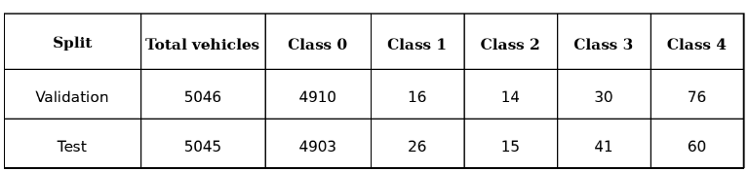
Fig. 4 Class distribution in the holdout data
Because of this imbalance, the project does not rely on accuracy alone. It also reports macro precision, macro recall, macro F1, weighted F1, and a challenge cost metric. The challenge cost is especially important in this research because it reflects predictive-maintenance priorities: predicting a near-failure vehicle as healthy is penalized much more heavily than producing an early warning. That makes it a more realistic measure of practical usefulness than raw accuracy alone.
The main comparison between the reactive baseline and the selected AI model is shown in Table III.2. For the AI side, the repository chooses the model with the lowest mean challenge cost on the test set if no model is specified manually. Under the current results, that model is Two-stage CatBoost. The methodology file explains that this model is preferred not because it is universally the best classifier, but because under this dataset and cost structure it provides the most useful predictive-maintenance trade-off among the currently implemented models.
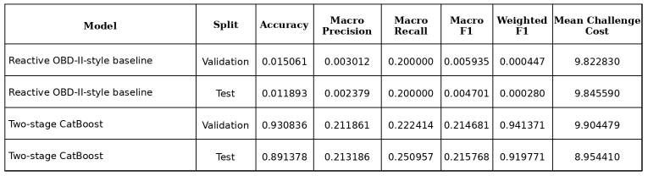
Fig. 5 Main comparison results
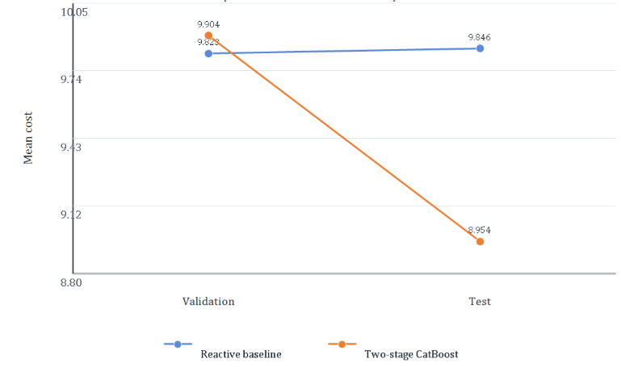
Fig. 5 Mean Challenge Cost
Once the data is presented in this way, the contrast becomes easier to interpret. The reactive baseline performs extremely poorly on both validation and test data. That is not surprising when its design is considered carefully. Since it relies only on the latest readout and reduces all abnormality to one aggregated anomaly score, it does not have enough information to distinguish subtle differences between the five failure windows. It behaves much more like a rough alerting mechanism than a true predictive system. In that sense, its low performance is not merely a technical weakness; it also supports the central idea of the research. Conventional reactive diagnostics are useful for noticing abnormal present-state behavior, but they are not naturally suited for estimating how close a system is to a future failure event.
The AI model behaves differently because it uses a much richer presentation of the vehicle. According to the methodology note, the predictive pipeline builds one row per vehicle snapshot and includes metadata features, last values, means, standard deviations, deltas, and static specification features from the Spec_* columns. The TS CatBoost model then solves the problem hierarchically: first it predicts whether the vehicle belongs to class 0 or to a future-failure class, and only then does it refine the prediction among classes 1 to 4. This structure is particularly useful in an imbalanced setting because it prevents the model from being dominated too strongly by the healthy majority class in a single flat decision step.
At the same time, the results should not be overstated. The AI model clearly outperforms the reactive baseline, especially when judged by cost-sensitive and class-aware metrics, but its macro-level values still show that the minority classes remain difficult. This is why relying on accuracy alone and also explains why single-stage CatBoost, despite having the highest raw test accuracy among the AI systems, is not treated as the main comparison model. It behaves too much like a majority-class classifier on the minority fault windows. Two-stage CatBoost is considered more meaningful because it retains high overall performance while improving minority sensitivity and producing the lowest mean challenge cost among the available AI models.
Taken together, the analysis points to a balanced conclusion. The reactive baseline is valuable because it gives the research a clear and interpretable proxy for conventional OBD-II-style diagnostic logic. Its threshold-based structure is simple, readable, and conceptually close to traditional diagnostics. However, that same simplicity limits its usefulness when the task shifts from detecting current abnormality to estimating future failure proximity. The AI model performs better not because it replaces that logic entirely, but because it has access to more informative features and is optimized under an evaluation scheme that reflects real maintenance priorities. The overall result is therefore not that reactive diagnostics are irrelevant, but that they are not sufficient on their own when the goal becomes predictive maintenance rather than reactive fault confirmation.
- Conclusion
Concluding this research examined the difference between traditional OBD-II-style diagnostics and AI-based predictive maintenance in the context of modern vehicle maintenance. Although both approaches deal with vehicle condition and fault-related information, they do not solve the same problem in the same way. Traditional diagnostics are primarily reactive. They are useful for identifying faults that have already become visible enough for the vehicle to recognize and report. AI-based systems, on the other hand, are designed to look beyond the current fault state and estimate whether the observed behavior suggests that a failure may be approaching. Because of that, the comparison in this research was not treated as a simple competition between an “old” and a “new” technology, but as a comparison between two different diagnostic philosophies.
The theoretical part of the research showed that OBD-II remains a very important foundation in vehicle diagnostics. Its value lies in standardization, accessibility, and practical usefulness. In workshops and everyday maintenance, it is still one of the fastest and most understandable ways to retrieve fault information, inspect live values, and begin troubleshooting. At the same time, its limitations are equally clear. It depends heavily on the user’s interpretation and, more importantly, it is built around faults that have already reached a detectable threshold. That makes it useful for confirmation and diagnosis, but much less suitable for estimating what may happen next.
The experimental research of the paper reinforced that distinction. Since the SCANIA Component X dataset is not a direct OBD-II fault-code dataset, the traditional side of the comparison was represented through a reactive rule-based baseline that followed the logic of conventional OBD-II-style diagnostics. This baseline was intentionally simple: it relied on the most recent sensor values, compared them to a healthy reference, and converted their deviation into an anomaly-based severity class. In that sense, it served as a reasonable proxy for reactive diagnostics, but its weaknesses also became obvious. Its performance showed that a threshold-based system can be transparent and easy to explain while still being too limited for a predictive task in which subtle differences between future failure windows matter.
The AI-based model performed better because it worked with a much richer view of the vehicle state. Rather than relying only on the latest reading, it used historical sensor behavior, summary statistics, and static specification features to form its predictions. This gave it a more realistic chance of recognizing patterns related to future failure. Even so, the results also showed that this is not an easy problem. The strong class imbalance in the dataset means that high overall accuracy can be misleading, especially when most vehicles belong to the healthy class. For that reason, this research placed particular attention on class-aware and cost-sensitive evaluation, rather than on accuracy alone. From that perspective, the selected AI model showed a meaningful advantage over the reactive baseline, especially in terms of practical usefulness for maintenance planning.
At the same time, the findings should be interpreted carefully. The results do not suggest that traditional diagnostics have become obsolete, nor do they show that AI-based predictive maintenance has solved the problem completely. The minority classes in the dataset remain difficult, and even the stronger predictive model still leaves room for improvement. What the results do show is something more modest, but also more realistic: a reactive diagnostic logic is not sufficient on its own when the goal shifts from confirming existing abnormalities to estimating how close a system may be to failure. In that setting, a data-driven predictive approach is simply better aligned with the problem.
Overall, the main takeaway of this research is that traditional OBD-II-style diagnostics and AI-based predictive maintenance should not be viewed as direct opposites. They are better understood as complementary approaches. OBD-II remains highly valuable for practical fault detection, inspection, and troubleshooting, while AI-based systems offer a more promising direction when earlier warning and maintenance planning are required. The future of vehicle diagnostics will likely not belong entirely to one of these approaches, but to systems that combine the clarity and accessibility of conventional diagnostics with the predictive capabilities of machine learning. That combination is where the most practical long-term value seems to lie.
References
- California Bureau of Automotive Repair, On-Board Diagnostic Test Reference, California Bureau of Automotive Repair, 2015–2026 revision history. Available: https://www.bar.ca.gov/obd-test-reference.
- U.S. Environmental Protection Agency, Vehicle Emissions Inspection and Maintenance (I/M): Information for State and Local I/M Agencies, U.S. EPA. Available: https://www.epa.gov/state-and-local-transportation/vehicle-emissions-inspection-and-maintenance-im-information-state.
- D. Sosnowski, E. Gardetto, Performing Onboard Diagnostic System Checks as Part of a Vehicle Inspection and Maintenance Program, U.S. Environmental Protection Agency, EPA-420-R-01-015, June 2001. Available: https://nepis.epa.gov/Exe/ZyPURL.cgi?Dockey=P1002KRN.TXT.
- Kvaser AB, Introduction to the OBD II Standard, Kvaser Learning Center. Available: https://kvaser.com/about-can/can-standards/introduction-to-obd-ii/.
- F. Arena, M. Collotta, L. Luca, M. Ruggieri, F. G. Termine, Predictive Maintenance in the Automotive Sector: A Literature Review, Mathematical and Computational Applications, vol. 27, no. 1, p. 2, 2022. Available: https://doi.org/10.3390/mca27010002.
- Z. Kharazian, T. Lindgren, S. Magnússon, O. Steinert, O. Andersson Reyna, SCANIA Component X Dataset: A Real-World Multivariate Time Series Dataset for Predictive Maintenance, Researchdata.se, DOI: 10.58141/1w9m-yz81, 2024. Available: https://researchdata.se/en/catalogue/dataset/2024-34.

